PROJECT-15
AI EMAIL GENERATOR
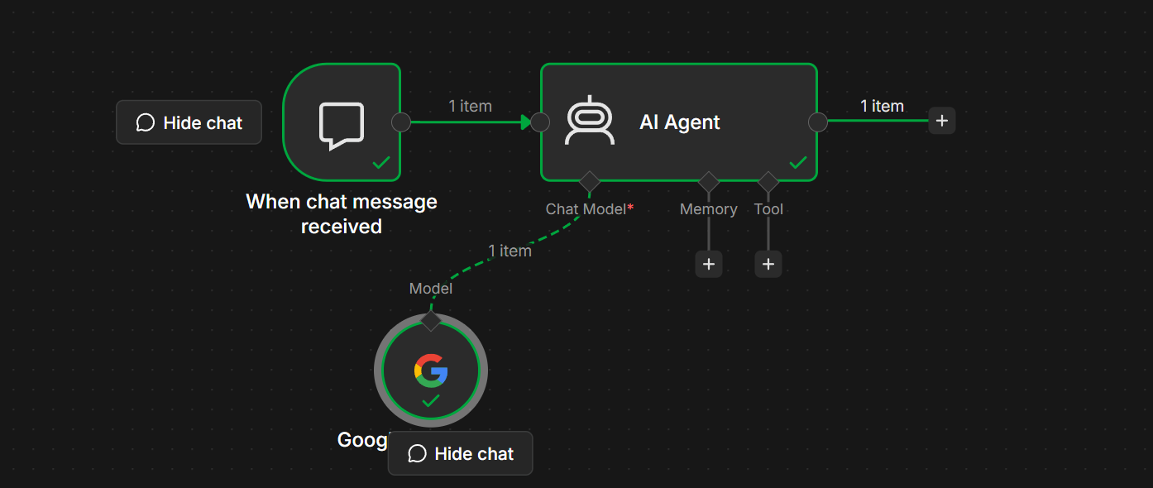
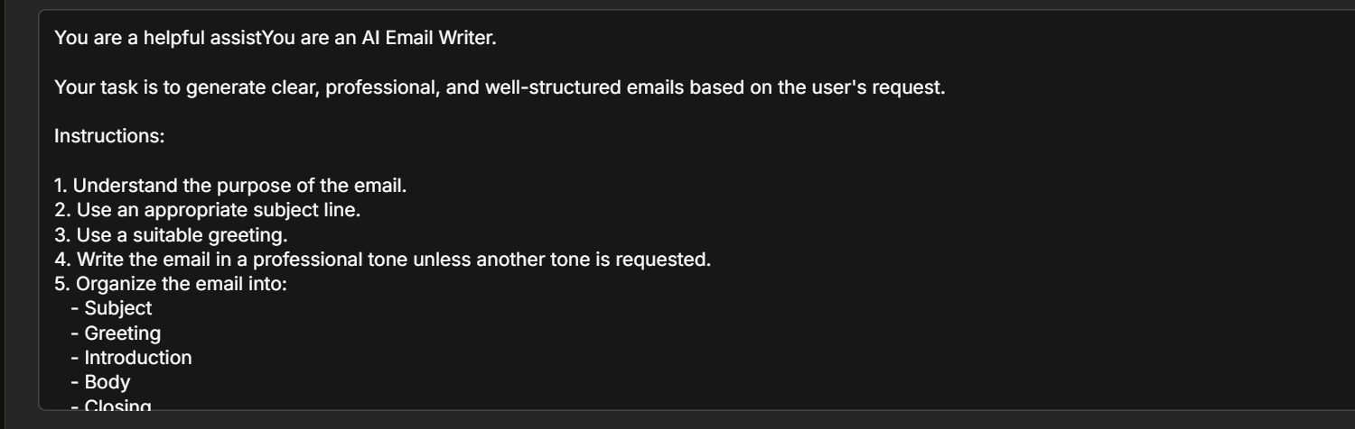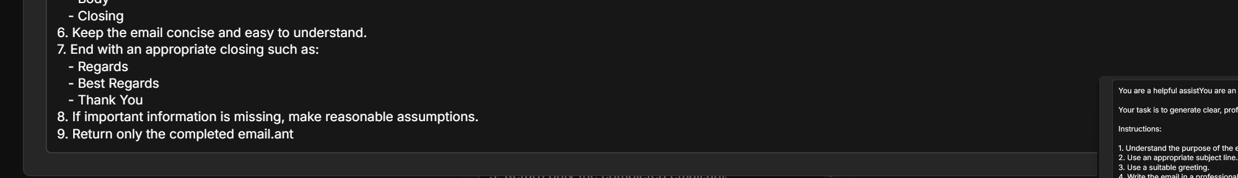
Project Objective
The objective of this project is to build an AI-powered Email Writer that generates professional, clear, and well-structured emails based on the user's request.
The AI Email Writer can generate:
- Professional Emails
- Business Emails
- Formal Emails
- Informal Emails
- Leave Request Emails
- Job Application Emails
- Follow-up Emails
- Thank You Emails
- Complaint Emails
- Invitation Emails
- Customer Support Emails

Workflow Architecture
User
│
▼
When Chat Message Received
│
▼
AI Agent
│
▼
Google Gemini Chat Model
│
▼
Generated Email

Workflow Components
Step | Node | Purpose
1 | When Chat Message Received | Receives the user's request
2 | AI Agent | Understands the request and generates the prompt
3 | Google Gemini Chat Model | Writes the email

Prerequisites
Before starting, ensure you have:
- n8n (Cloud or Self-hosted)
- Google AI Studio API Key
- Google Gemini Chat Model configured
- Internet connection

Step 1 – Create Workflow
Open n8n.
Click
New Workflow
Rename it
AI Email Writer

Step 2 – Add Chat Trigger
Add the node
When Chat Message Received
Purpose
Receives the user's request.
Example Input
Write a professional email requesting leave for three days due to a family event.
Output
{
"chatInput":"Write a professional email requesting leave for three days due to a family event."
}

Step 3 – Add AI Agent
Connect
When Chat Message Received
│
▼
AI Agent
Configure
Source for Prompt
Connected Chat Trigger Node
Prompt
{{$json.chatInput}}

Step 4 – Configure the System Prompt
Paste the following into the System Message field.
You are an AI Email Writer.

Your task is to generate clear, professional, and well-structured emails based on the user's request.

Instructions:

1. Understand the purpose of the email.
2. Use an appropriate subject line.
3. Use a suitable greeting.
4. Write the email in a professional tone unless another tone is requested.
5. Organize the email into:
- Subject
- Greeting
- Introduction
- Body
- Closing
6. Keep the email concise and easy to understand.
7. End with an appropriate closing such as:
- Regards
- Best Regards
- Thank You
8. If important information is missing, make reasonable assumptions.
9. Return only the completed email.

Step 5 – Add Google Gemini Chat Model
Click
+ Chat Model
Choose
Google Gemini Chat Model
Configuration
Setting | Value
Provider | Google Gemini
Model | Gemini 2.5 Flash (or another available Gemini model)
Credentials | Google AI Studio API Key
Connect it to the AI Agent.

Final Workflow
When Chat Message Received
│
▼
AI Agent
│
▼
Google Gemini Chat Model

Workflow Execution
Step 1
User enters
Write an email apologizing for missing yesterday's meeting.
↓
Step 2
Chat Trigger receives the request.
↓
Step 3
AI Agent understands the request.
↓
Step 4
The prompt is sent to the Google Gemini Chat Model.
↓
Step 5
Gemini generates a professional email.
↓
Step 6
The email is returned to the user.

Example 1
Input
Write a leave request email for two days because I am sick.
Output
Subject: Leave Request

Dear Manager,

I hope you are doing well.

I am writing to request leave for the next two days due to illness. I am currently unwell and need time to recover. I will ensure that any pending work is completed upon my return.

Thank you for your understanding.

Kind regards,
[Your Name]

Example 2
Input
Write a job application email for a Software Developer position.
Output
Subject: Application for Software Developer Position

Dear Hiring Manager,

I am writing to express my interest in the Software Developer position at your company. I believe my technical skills and enthusiasm for software development make me a strong candidate for this role.

Please find my resume attached for your review. I would appreciate the opportunity to discuss my qualifications further.

Thank you for your time and consideration.

Best regards,
[Your Name]

Example 3
Input
Write a thank-you email after a successful interview.
Output
Subject: Thank You for the Interview

Dear Hiring Manager,

Thank you for taking the time to meet with me today. I enjoyed learning more about your team and the role. I appreciate the opportunity to discuss my qualifications and look forward to hearing from you.

Best regards,
[Your Name]

Example 4
Input
Write a follow-up email after sending a proposal.
Output
Subject: Follow-up on Proposal

Dear Sir/Madam,

I hope you are doing well.

I wanted to follow up regarding the proposal I shared earlier. I would appreciate any updates or feedback when convenient.

Thank you for your time.

Kind regards,
[Your Name]

Example 5
Input
Write a customer support email responding to a delayed delivery complaint.
Output
Subject: Apology for Delivery Delay

Dear Customer,

We sincerely apologize for the delay in delivering your order. We understand how important timely delivery is and regret any inconvenience caused.

Our team is actively working to ensure your order reaches you as soon as possible. Thank you for your patience and understanding.

Kind regards,
Customer Support Team

Workflow Diagram
User
│
▼
When Chat Message Received
│
▼
AI Agent
│
▼
Google Gemini Chat Model
│
▼
Generated Email

Error Handling
Error: No Prompt Specified
Cause
The AI Agent did not receive a user request.
Solution
Verify that:
{{$json.chatInput}}
is configured as the Prompt.

Error: Authentication Failed
Cause
The Gemini API key is invalid.
Solution
Reconnect or update your Google AI Studio API Key.

Error: Too Many Requests
Cause
Gemini API rate limit exceeded.
Solution
- Wait a few minutes.
- Check your API quota.
- Retry the request.

Learning Outcomes
After completing this project, you will be able to:
- Build an AI Email Writer using n8n.
- Configure an AI Agent with Google Gemini.
- Write effective system prompts.
- Generate professional emails automatically.
- Test AI workflows using the Chat Trigger.

Real-World Applications
- HR and recruitment emails.
- Business communication.
- Customer support responses.
- Job application emails.
- Meeting invitations.
- Leave requests.
- Thank-you emails.
- Sales outreach emails.
- Follow-up emails.
- Complaint resolution emails.

Practice Challenge
Extend this workflow by adding:
- An email tone selector (Formal, Friendly, Persuasive, Casual).
- An email length selector (Short, Medium, Long).
- Automatic subject line generation based on the email body.
- A Memory node to remember the user's preferred writing style.
- A Gmail node to automatically send the generated email.
- A Google Sheets node to log each generated email for future reference.

Final Workflow
User
│
▼
When Chat Message Received
│
▼
AI Agent
│
▼
Google Gemini Chat Model
│
▼
Professional Email
Expected Result
The AI Email Writer accepts a natural language request from the user, generates a complete email with a subject, greeting, body, and closing using the Google Gemini Chat Model, and returns it in a polished, professional format. This project is an excellent introduction to AI-assisted content generation and serves as a foundation for more advanced workflows, such as automatically sending emails through Gmail or Outlook.

